***CROP PRODUCTION PREDICTION***

**1. Introduction**

This report provides an overview of the approach, data preprocessing, exploratory data analysis (EDA), modeling, and key insights derived from the crop production prediction project.

**2. Data Preprocessing**

**2.1 Data Loading**

The dataset is loaded from an FAOSTAT Excel file and structured for analysis.

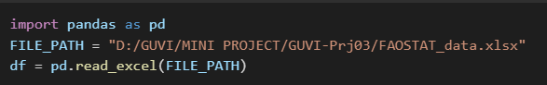

**2.2 Data Cleaning Steps**

Trimmed column names.

Renamed columns for clarity.

Filtered relevant elements ('Area harvested', 'Yield', 'Production').

Pivoted the dataset to improve structure.

Handled missing values by filling them with zero.

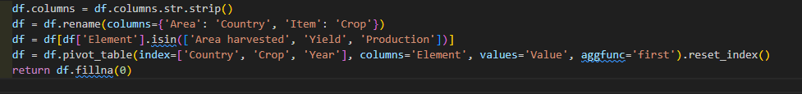

**3. Exploratory Data Analysis (EDA)**

**3.1 Data Overview**

Displaying initial data structure and key statistics.

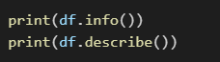

**3.2 Data Visualization**

Production Trend Over Time

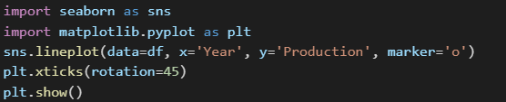

Outlier Detection in Production



Relationship between Area Harvested and Production



**4. Model Development**

**4.1 Data Splitting**

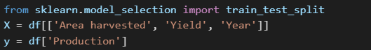



**4.2 Training the Model**

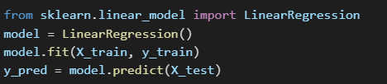

**4.3 Model Performance**

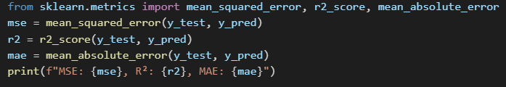

**5. Predictions**

**5.1 User Input-Based Predictions**

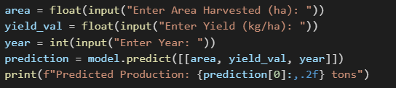

**6. Key Findings & Insights**

Production trends: The dataset shows a general increase in crop production over the years.

Yield impact: Higher yield per hectare significantly boosts production.

Geographic differences: Different countries exhibit variations in agricultural productivity.

Model accuracy: The linear regression model provides reasonable predictions with an R² value indicating moderate explanatory power.

**7. Actionable Insights**

Optimizing Yield: Farmers should focus on improving yield per hectare using better farming techniques.

Resource Allocation: Governments can allocate resources based on historical production trends.

Future Forecasting: This model can help policymakers plan for future agricultural production needs.

**8. Conclusion**

This analysis provides valuable insights into agricultural production trends and helps in forecasting future crop production efficiently using machine learning techniques.